**Counterfeit Discriminant ICE**

MANGO, a Spanish designer wear brand available in India, is worried about losing sales to counterfeiters. Hence, they come up with a fighter brand, called Mango Lite and conduct the following experiment where they show posters to 30 subjects and ask them for their choice (original, fighter brand or counterfeit). Please see the experimental stimuli below in Appendix A and then the data in the file “counterfeit discriminant data.sav”. Analyse the data.

1. Can you discriminate between the subjects on the basis of the various variables measured and advise the company?
2. A new customer, Rohit, walks into its store a few days later. Rohit is aged 32, has a status consciousness score of 4.2, a tight money situation score of 3.5, sense of personal ethics score of 4. He has 5 other members in his household (apart from him) and has an income of Rs. 65000 per month. What would he likely buy?
3. Should MANGO introduce a fighter brand or not? Can you conclude? If yes, how? If no, what else should MANGO do to concude?

**Appendix A: Experimental Stimuli**

MANGO, is a clothing design and manufacturing company, founded in Barcelona, Catalonia (Spain) Branching from the helm of exclusivity, and attuned to novelty, the label MANGO springs from the alliance between a quality product of unique design and a brand image which is both coherent and unified. With garments that are made to own you, today everything that is not Mango has become a bit passé.

**MANGO Lite** was recently launched by MANGO for the aspiring MANGO shopper, which is about affordable fashion

Assume that you are out shopping and come across stores selling the following..

**Original Mango products at their Classy best**

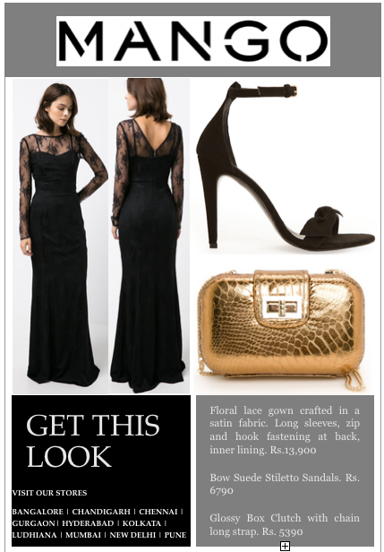

**Stunning products from MANGO's younger, more affordable brand – MANGO Lite**

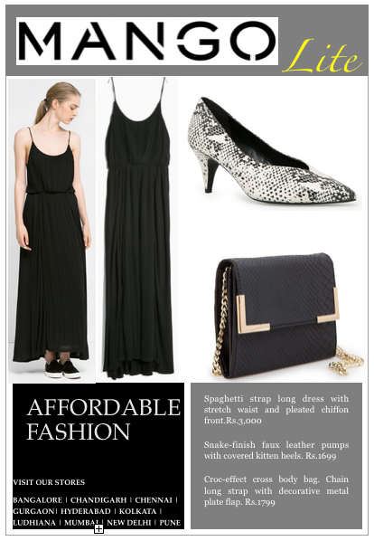

**Counterfeited MANGO products**

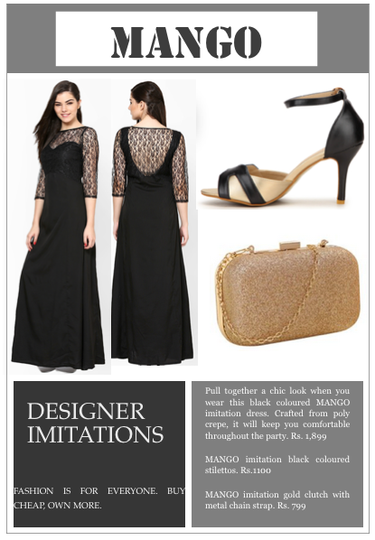

If you were to choose to buy from these three choices, what would you choose?

*  Original MANGO Products
*  MANGO Lite Products
*  Imitation MANGO Products